FAQs: Smoking Abstinence Prior to Elective Surgery
WHAT IS THE REQUIREMENT?
PacificSource Community Solutions follows OHA’s Prioritized List of Health Services Ancillary Guideline A4 which requires patients to quit smoking for 30 days in advance of elective surgery. For elective surgical procedures requiring prior authorization, there are two requirements when submitting an elective surgical procedure request: (1) objective evidence of abstinence from smoking, and (2) relevant chart notes. See next page for a basic workflow option.

WHAT IS THE DEFINITION OF ELECTIVE SURGERY?
Elective surgical procedures are defined as those, which are flexible in their scheduling because the condition does not pose an imminent threat nor does it require immediate attention within one month.

ARE THERE ANY SURGERIES THAT ARE EXCEPTIONS TO THIS GUIDELINE?
Reproductive (i.e. for contraceptive purposes), cancer-related and diagnostic procedures are excluded from this guideline. Certain other procedures, such as lung volume reduction surgery, bariatric surgery, erectile dysfunction surgery, and spinal fusion have 6-month smoking abstinence requirements, per Guideline Notes 8, 100, 112 and 159.

WHO IS CONSIDERED A SMOKER?
A smoker is anyone currently smoking cigarettes, or someone who has abstained from smoking for less than one year. For patients who have quit smoking cigarettes for at least one full year, a documented attestation is sufficient.

WHY IS SMOKING CESSATION PRIOR TO SURGERY SO IMPORTANT? WHAT CAN I TELL MY PATIENTS?
From the American College of Surgeons: Smoking increases your risk of problems during and after your operation. Quitting 4 to 6 weeks before your operation and staying smoke-free 4 weeks after it can decrease your rate of wound complications by 50 percent.
From the American Association of Orthopaedic Surgeons: Smoking has a negative effect on fracture and wound healing after surgery. Broken bones take longer to heal in smokers because of the harmful effects of nicotine on the production of bone-forming cells.
From the American Society of Anesthesiologists: After surgery, you are much more likely to need a ventilator
– a machine that breathes for you – because of your increased risk of breathing and lung problems.

WHAT ARE THE PROOF-OF-ABSTINENCE TESTING OPTIONS, ISSUES, AND REFERENCE RANGES?
Testing options for cigarette smoking abstinence include urine or blood tests for cotinine (a metabolite of nicotine) or anabasine (a tobacco-specific biomarker), or an exhaled carbon monoxide test. It is well-known that patients using nicotine replacement therapies (NRTs) test positive for cotinine. Therefore, either anabasine or exhaled CO tests should be ordered for those patients. Some foods may also trigger positive cotinine values. Testing laboratories offer a reflex test for anabasine, if cotinine is detected first. Billing codes for all tests can be found on the workflow on the next page.

Neither OHA nor PacificSource can offer a negative cutoff value for these tests because they differ depending on individual laboratories’ reference ranges. For example, one laboratory’s anabasine cutoff is <2 ng/mL, while another’s is <3. This is because each lab’s assay process has its own sensitivities. However, the unit of measurement for anabasine is extremely small, and patients abstaining from cigarette smoking ought to be below those numbers after 30 days regardless of whether the cutoff is 2 or 3 ng/mL. Anabasine tests occasionally result in false negatives because of the compound’s low concentration in tobacco.

For questions, please contact Customer Service (800) 431-4135
Last updated 7/30/2019

WORKFLOW: SUPPORTING AND OBTAINING EVIDENCE FOR SMOKING ABSTINENCE PRIOR TO ELECTIVE SURGERY

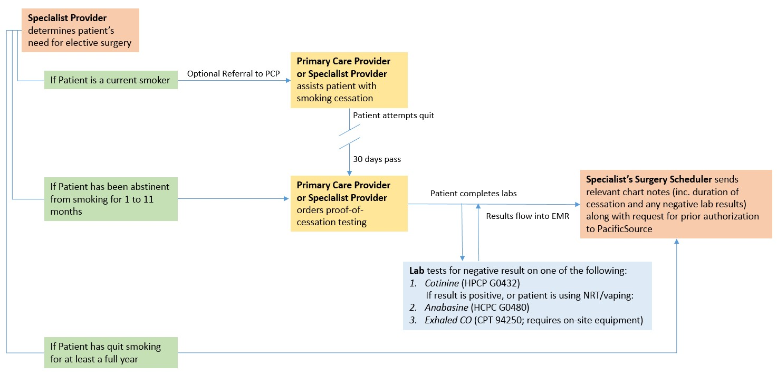

For questions, please contact Customer Service (800) 431-4135 Last updated 7/30/2019

